**ITL-3 Practical 1**

**Q:** Maintain record of students and perform CRUD functionality.

**A:**

Within computer programming, the acronym CRUD stands for create, read, update and delete. These are the four basic functions of persistent storage. Also, each letter in the acronym can refer to all functions executed in relational database applications and mapped to a standard HTTP method, SQL statement or DDS operation.

It also describes user-interface conventions that allow viewing, searching and modifying information through computer-based forms and reports. In essence, entities are read, created, updated and deleted. Those same entities can be modified by taking the data from a service and changing the setting properties before sending the data back to the service for an update. Plus, CRUD is data-oriented and the standardized use of HTTP action verbs.

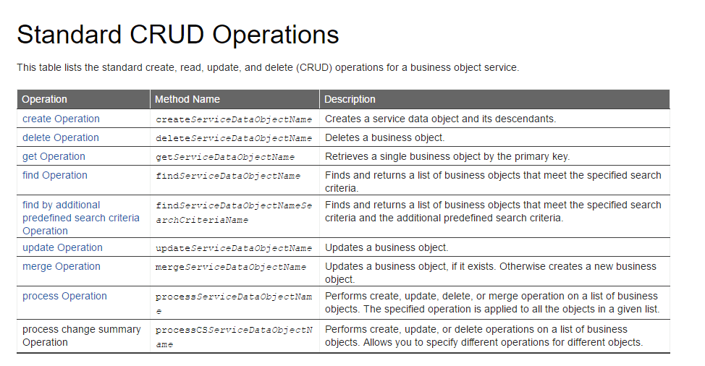

Most applications have some form of CRUD functionality. In fact, every programmer has had to deal with CRUD at some point. Not to mention, a CRUD application is one that utilizes forms to retrieve and return data from a database.

The first reference to CRUD operations came from Haim Kilov in 1990 in an article titled, “From semantic to object-oriented data modeling.” However, the term was first made popular by James Martin’s 1983 book, Managing the Data-base Environment. Here’s a breakdown:

* CREATE procedures: Performs the INSERT statement to create a new record.
* READ procedures: Reads the table records based on the primary keynoted within the input parameter.
* UPDATE procedures: Executes an UPDATE statement on the table based on the specified primary key for a record within the WHERE clause of the statement.
* DELETE procedures: Deletes a specified row in the WHERE clause.

**How CRUD Works: Executing Operations and Examples**

Based on the requirements of a system, varying user may have different crud cycles. A customer may use CRUD to create an account and access that account when returning to a particular site. The user may then update personal data or change billing information. On the other hand, an operations manager might create product records, then call them when needed or modify line items.

During the Web 2.0 era, CRUD operations were at the foundation of most dynamic websites. However, you should differentiate CRUD from the HTTP action verbs. For example, if you want to create a new record you should use “POST.” To update a record, you would use “PUT” or “PATCH.” If you wanted to delete a record, you would use “DELETE.” Through CRUD, users and administrators had the access rights to edit, delete, create or browse online records.

An application designer has many options for executing CRUD operations. One of the most efficient of choices is to create a set of stored procedures in SQL to execute operations. With regard to CRUD stored procedures, here are a few common naming conventions:

* The procedure name should end with the implemented name of the CRUD operation. The prefix should not be the same as the prefix used for other user-defined stored procedures.
* CRUD procedures for the same table will be grouped together if you use the table name after the prefix.
* After adding CRUD procedures, you can update the database schema by identifying the database entity where CRUD operations will be implemented.